**VELAMMAL BODHI CAMPUS**

**(A CBSE – IIT/NEET Integrated Sr. Sec. School)**

**GRAND TEST – III (2023-24)**

**Grade:** X Batch I  **Sub:** Social Science

**Date:** 28.12.2023 **Marks:** 80

**General Instruction:**

*(i) This question paper has six sections: Section A, Section B, Section C, Section D, Section E, and Section F. There are 37 questions in the paper. All Questions are compulsory.*

*(ii) Section A contains 20 questions of one mark each (Q.1 to Q.20),*

*(iii) Section B contains 4 questions of two marks each (Q.21 to Q.24),*

*(iv) Section C contains 5 questions of three marks each (Q.25 to Q.29),*

*(v) Section D contains 4 questions of five marks each (Q.30 to Q.33),*

*(vi) Section E contains three case based (Subjective) four marks (Q.34 to Q.36),*

*(vii) Section F Question no.37 is map based, carrying 5 marks with two parts, 37.a from History (2 marks) and 37 b from Geography (3 marks),*

*(viii) There is no overall choice in the question paper. However, an internal choice has been provided in few questions. Only one of the choices in each questions have to be attempted. In addition to this separate instructions are given with each section and question where necessary.*

**Section – A (20x1=20)**

1. Choose the correction option to complete the statement.

If a government provides its citizens a right and means to examine the process of decision, it is -----------

(a) An accountable government (b) A responsible government

(c) A transparent government (d) A stable government

2. Which one of the following subjects comes under the legislation of Centre and State in India?

(a) Education (b) Forests (c) Banking (d) Trade

3. In India --------------- issues currency notes on behalf of the central government.

(a) SBI (b) RBI (c) IOB (d) PNB

4. What is meant by Liberty?

5. Which one of the following divisions is unique to India?

(a) Gender (b) Caste (c) Religion (d) Economic

6. Which on of the following Indian industries has been hit hard by globalization?

(a) IT (b) Toy Making (c) Jute (d) Cement

7. Most societies across the world were historically ---------- dominated societies

8. Which of the following revolutions is called as the first expression of ‘Nationalism’?

(a) French Revolution (b) Russian Revolution

(c) Glorious Revolution (d) The Revolution of the liberals

9. **Consider the statements given below and choose the correct answer.**

**Statement I**: Western printing techniques and mechanical press were imported in the late 19th century as western powers established their outposts in china

**Statement II**: Beijing became the hub of the new print culture, catering to western style schools.

(a) Statement (i) is correct and (ii) is Incorrect

1. Statement (i) is incorrect and (ii) is correct

(c) Both (i) & (ii) are incorrect (d) Both (i) & (ii) are correct

10. **Identify the correct option that describes the act given below**.

I. The act was passed by the imperial legislative council

II. It gave power to the government to repress political activities

III. It empowered the government to detain political prisoners without trail.

(a) Rowlatt Act (b) Vernacular press act

(c) Government of India Act (d) Inland Emigration Act

11. Laws concerning family matters such as marriage, divorce, adoption etc. are known as?

(a) Family Laws (b) constitutional Laws

(c) Criminal Laws (d) Civil Laws

12. Which place in India has an artificial lake to conserve water that dates to 11th century?

(a) Delhi (b) Bhopal (c) Mumbai (d) Kolhapur

13. ---------- region has the highest representation of women in their national parliament?

(a) Pacific (b) Americas (c) Middle East (d) Nordic Countries

14. ___________ is considered to be one of the most important attributes for development

(a) per capita income (b) Average literacy level

(c) health status of the people (d) safety

15. If there is disruption by transporters and lorries refuse to transport vegetables, milk, etc. From rural areas to urban areas food will become scarce in urban areas, whereas farmers will be unable to sell their products. Which of the following sectors will be affected due to this situation stated above?

(a) Primary and Secondary (b) Secondary and Tertiary

(c) Tertiary, Primary and Secondary (d) Tertiary and Primary

16. The process of integration between different countries is called as ----------

(a) Privatization (b) Globalization

(c) Liberalization (d) Competition

17. **Which of the following options represent potential measure that can be taken to mitigate the threats posed on the tiger population and biodiversity?**

i.Banning hunting, giving legal protection to their habitats, and restricting trade in wildlife

ii. Prohibiting the visit of public into forest area.

iii. Establishing wildlife sanctuaries and national parks

iv. converting forests into Reserved and protected forests

(a) Statement i and ii are correct (b) Statement ii, iii & iv are correct

(c) Statement ii is correct (d) Statement i, ii, & iv are correct

18. Kudremukh is an import Iron mine of -----------

(a) Assam (b) Gujarat (c) Karnataka (d) Chhattisgarh

19. ------- percentage of the poor people in India are depends on informal sources of credit

(a)15% (b) 35% (c) 85% (d) 50%

20. Removing barriers or restrictions set by the government is known as -----

(a) Globalisation (b) Disinvesment (c) Privatisation (d) Liberalisation

**Section – B (4x2=8)**

21. Which two factors moved the centre of world trade westwards?

22. Mention any two reasons to prove that India is a federal Country.

23. In what ways Government can increase employment in the rural sector?

24. Suggest some ways to improve the usage of Solar energy.

**Section – C (5x3=15)**

25. (a) “The silk routes are a good example of pre-modern trade and cultural links between distant parts of the world.” Explain with examples.

**Or**

(b) Many a times introduction of new crops make the difference life and death. Explain the Statement with the example of introduction potato crop in Europe

26. What are some negative aspect of caste in politics?

27. Establish the difference between Commercial farming and Subsistence farming with the help of a suitable example.

28. State the role of Reserve Bank Of India?

29. How can workers in the unorganized sector be protected?

**Section – D (4x5=20)**

30. **A**. How was the social and political situation of India affected by the First World War? Explain.

**Or**

**B**. How did the Indian merchants and industrialists relate themselves to the Civil Disobedience Movement? Explain.

31. **A**. Describe the role of political parties in India.

**Or**

**B**. Describe the necessity or utility of political parties in democratic countries

32. **A**. Analyse the impact of mining activities on the local environment and the health of the surrounding communities.

**OR**

**B**. “Non-conventional resources are the best option to conserve the natural resources” Substantiate this statement with Examples.

33. **A**. Compare and contrast the conditions for taking loans from formal and informal sources. Suggest an alternative source that you think is best for the rural poor.

**(OR)**

**B**. Imagine yourself to be XYZ, a member of women Self- Help Group. Analyze the Ways through Which Your provides loans to the members?

**Section – E (3x4=12)**

**34. Read the source given below and answer the following questions.**

It is said of “passive resistance” that it is the weapon of the weak, but the power which is the subject of this article can be used only by the strong. This power is not passive resistance; indeed, it calls for intense activity. The movement in South Africa was not passive but active … 'Satyagraha is not physical force. A satyagrahi does not inflict pain on the adversary; he does not seek his destruction … In the use of satyagraha, there is no ill will whatever. 'Satyagraha is pure soul force. Truth is the very substance of the soul. That is why this force is called satyagraha. The soul is informed with knowledge. In it burns the flame of love. … Nonviolence is the supreme dharma …' It is certain that India cannot rival Britain or Europe in force of arms. The British worship the war god and they can all of them become, as they are becoming, bearers of arms. The hundreds of millions in India can never carry arms. They have made the religion of non-violence their own … In his famous book Hind Swaraj (1909) Mahatma Gandhi declared that British rule was established in India, with the cooperation of Indians, and had survived only because of this cooperation. If Indians refused to cooperate, British rule will collapse within a year.

34.1. Why did Gandhiji say that passive resistance is not the weapon of the weak? (1)

34.2. “Satyagraha is pure soul-force.” Substantiate this statement in 20 words. (1)

34.3. What according to Mahatma Gandhi is the best weapon to use to collapse British rule in India? (2)

35. **Read the source given below and answer the following questions.**

Narmada Bachao Andolan or Save Narmada Movement is a Non-Governmental Organisation (NGO) that mobilized tribal people, farmers, environmentalists and human rights activists against the Sardar Sarovar Dam being built across the Narmada river in Gujarat. It originally focused on the environmental issues related to trees that would be submerged under the dam water. Recently it has re-focused the aim to enable poor citizens, especially the oustees (displaced people) to get full rehabilitation facilities from the government. People felt that their suffering would not be in vain… accepted the trauma of displacement believing in the promise of irrigated fields and plentiful harvests. So, often the survivors of Rihand told us that they accepted their sufferings as sacrifice for the sake of their nation. But now, after thirty bitter years of being adrift, their livelihood having even being more precarious, they keep asking: “Are we the only ones chosen to make sacrifices for the nation?”

*Source: S. Sharma, quoted in* In the Belly of the River. Tribal conflicts over development in Narmada valley. A. Baviskar. 1995.

35.1 With what objective ‘Sardar Sarovar Dam’ was built? (1)

35.2 Analyse the reason of protest by the tribal people. (1)

35.3 Highlight the issues on which ‘Save Narmada Movement’ worked on. (2)

**36. Read the passage below and answer the following questions:**

Power sharing arrangements can also be seen in the way political parties, pressure groups and movements control or influence those in power. In a democracy, the citizens must have freedom to choose among various contenders for power. In contemporary democracies, this takes the form of competition among different parties. Such competition ensures that power does not remain in one hand. In the long run, power is shared among different political parties that represent different ideologies and social groups. Sometimes this kind of sharing can be direct, when two or more parties form an alliance to contest elections. If their alliance is elected, they form a coalition government and thus share power. In a democracy, we find interest groups such as those of traders, businessmen, industrialists, farmers and industrial workers. They also will have share in governmental power, either through participation in governmental committees or bringing influence on the decision-making process.

36.1 ‘Power sharing is an essential component of democracy.’ Give one example to prove the statement. (**1)**

36.2 How is alliance building an example of power sharing? (**1)**

36.3 How Political parties, pressure groups and movements help in controlling or influencing those who are in power? (**2)**

**Section – F (2+3=5)**

**Locate the following place/ Region on India’s political map:**

37. **A. History**

Two places have been marked on the given outline map of India. Identify them and write their correct names on the lines drawn them.

(A) The place where the Indian National Congress Session was held in 1927.

(B) The place where Gandhiji organized "Satyagraha' in favour of plantation workers.

37. **B. Geography**

On the same outline map of India locate and label **ANY THREE** of the following with suitable symbols. (3)

(1) Chhatrapati Shivaji - International Airport (2) Durgapur - Iron and Steel Plant

(3) A Nuclear power Plant in Uttar Pradesh (4) A Dam built on the river Mahanadi

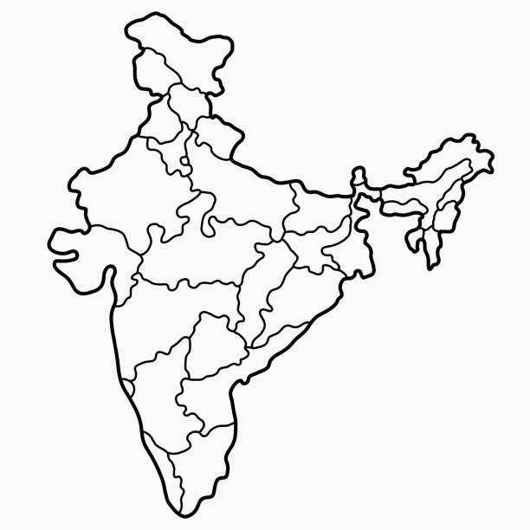

**A**

**B**

***\*\*\* ALL THE BEST \*\*\****